**CAMPIONAT DE KARTING**

**Prof. Laborator: Anamaria Stefania Zanoaga**

**Prof. Curs: Gabriela Mihai**

**Mircea Andrei Razvan**

**Grupa 232**

Cuprins

Descriere baza de date 2

Diagrama Entitate – Relatie 2

Diagrama conceptuala 3

Creare Tabele 3

Inserturi 16

Subprogram cu 3 colectii 27

2 Cursoare 29

Minim 3 tabele (pilot + staff + participa + etapa) 31

Minim 5 tabele 34

Minim 5 tabele (v2) 37

Trigger LMD la nivel de comanda 41

Trigger LMD la nivel de linie 42

Trigger LDD 43

Pachet cu toate obiectele proiectului 44

3 Coletii 53

2 Cursoare 53

3 Tabele 53

5 Tabele 54

Pachet cu tipuri de date complexe 54

Lider categorie 59

Risc penalizare 61

Salariu staff 62

Top 3 piloti 64

# Descriere baza de date

Diagrama ajuta la procesul de organizare a unui campionat de karting. Campionatul este alcatuit din mai multe etape. La fiecare etapa participa mai multe echipe formate din piloti si mecanici. Pentru fiecare pilot exista macar un mecanic/staff care se ocupa de antrenarea acestuia. Fiecare membru staff detine minim o functie/un job. Fiecare pilot are un kart, ce poate fi principal sau de rezerva. Fiecare etapa este alcatuita din mai multe antrenamente, o sesiune de calificari si mai multe curse. De asemenea, fiecare etapa se desfasoara pe un circuit. Pe tot parcursul campionatului pot exista potentiali sponsori (in general, contractul dintre sponsor si campionat este pe toata durata campionatului, motiv pentru care nu exista o conexiune directa intre o etapa si un sponsor).

# Diagrama Entitate – Relatie

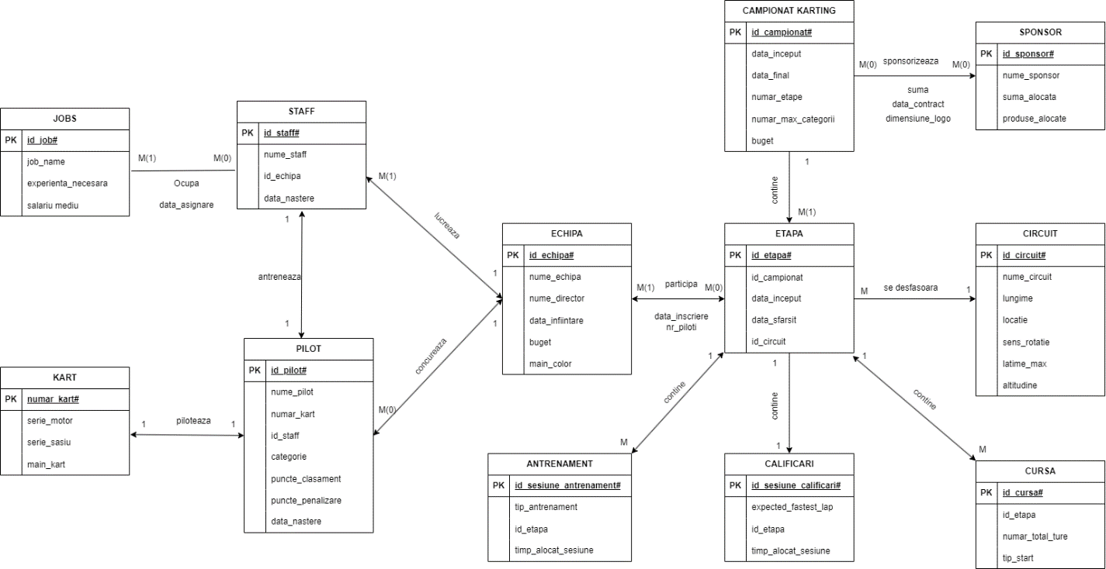

# Diagrama conceptuala

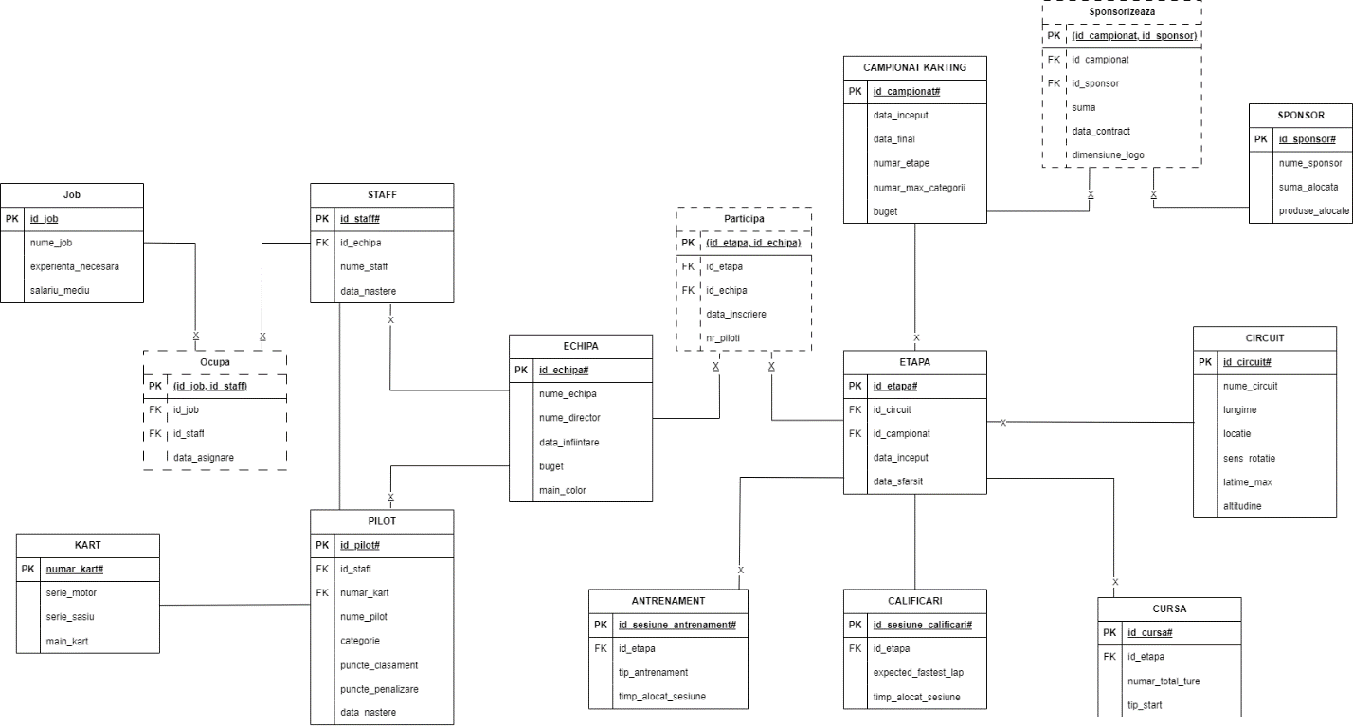

# Creare Tabele

create table Campionat_Karting

(

id_campionat number(10) constraint pk_campionat PRIMARY KEY,

data_inceput date constraint data_inceput_campionat not null,

data_final date constraint data_final_campionat not null,

numar_etape number(10),

numar_maxim_categorii number(10),

buget number(10)

);

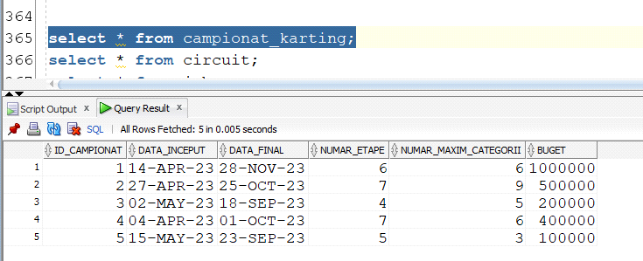

create table circuit

(

id_circuit number(10) constraint pk_circuit PRIMARY KEY,

nume_circuit varchar2(30),

lungime number(10),

locatie varchar2(30),

sens_rotatie varchar2(30) check(sens_rotatie in ('clockwise','anti-clockwise')),

latime_max number(2),

altitudine number(5)

);

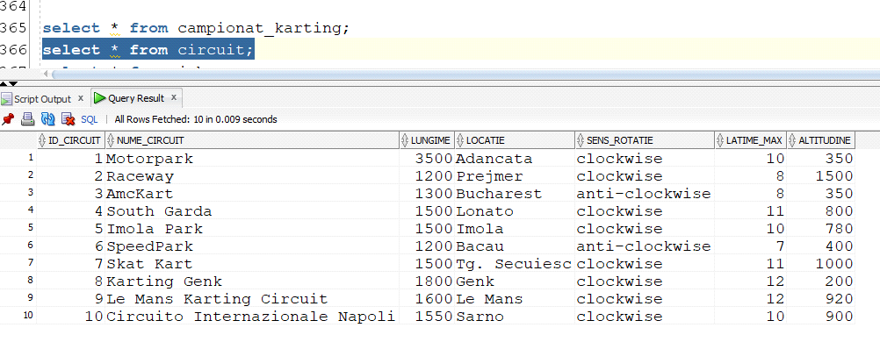

create table sponsor

(

id_sponsor number(10) constraint pk_sponsor PRIMARY KEY,

nume_sponsor varchar2(30),

suma_alocata number(10),

produs varchar2(30)

);

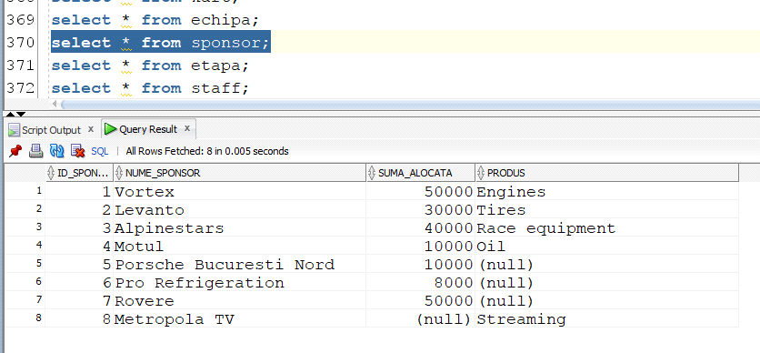

create table etapa

(

id_etapa number(10) constraint pk_etapa PRIMARY KEY,

data_inceput date constraint data_inceput_etapa not null,

data_final date constraint data_final_etapa not null,

id_campionat number(3),

id_circuit number(3),

FOREIGN KEY (id_campionat) references campionat_karting(id_campionat),

FOREIGN KEY (id_circuit) references circuit(id_circuit)

);

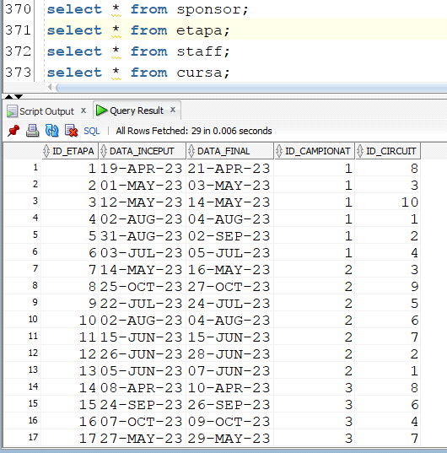

create table antrenament

(

id_antrenament number(10) constraint pk_antrenament PRIMARY KEY,

tip_antrenament varchar2(20),

timp_alocat_sesiune number(5),

id_etapa number(10),

FOREIGN KEY (id_etapa) references etapa(id_etapa)

);

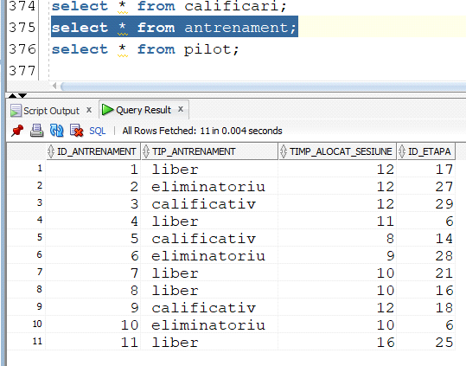

create table calificari

(

id_sesiune_calificari number(10) constraint pk_calificari PRIMARY KEY,

expected_fastest_lap varchar2(9),

timp_alocat_sesiune number(5),

id_etapa number(10),

FOREIGN KEY (id_etapa) references etapa(id_etapa)

);

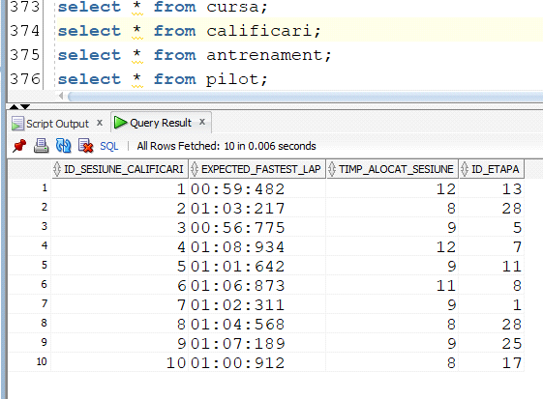

create table cursa

(

id_sesiune_cursa number(10) constraint pk_cursa PRIMARY KEY,

tip_start varchar2(20),

numar_total_ture number(5),

id_etapa number(10),

FOREIGN KEY (id_etapa) references etapa(id_etapa)

);

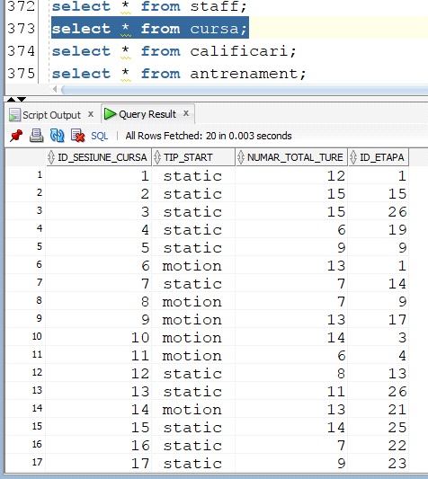

create table echipa

(

id_echipa number(10) constraint pk_echipa PRIMARY KEY,

nume_echipa varchar2(30),

nume_director varchar2(30),

data_infiintare date,

buget number(10),

main_color varchar2(30)

);

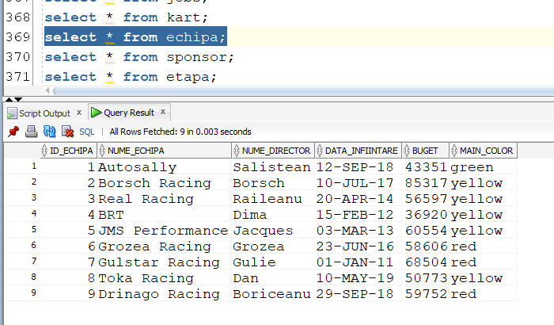

create table kart

(

numar_kart number(3) constraint pk_kart Primary key,

serie_motor number(10),

serie_sasiu number(10),

main_kart number(1) check (main_kart in (0,1))

);

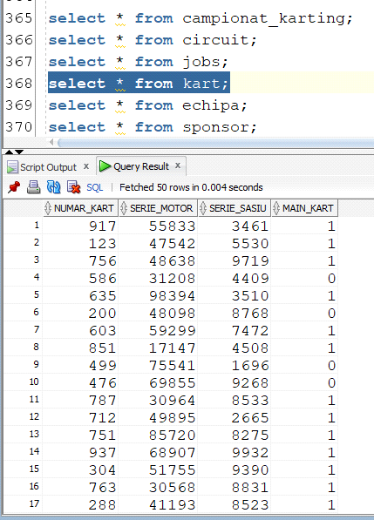

create table staff

(

id_staff number(10) constraint pk_staff PRIMARY KEY,

nume_staff varchar2(30),

id_echipa number(10),

data_nastere date,

FOREIGN KEY (id_echipa) references echipa(id_echipa)

);

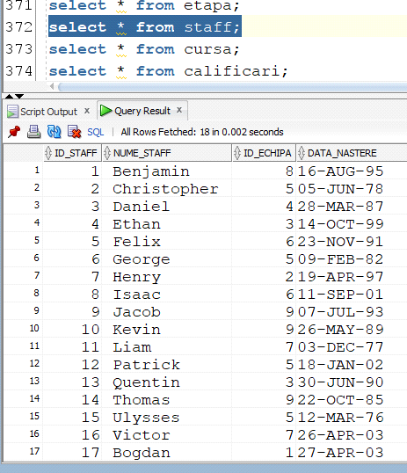

create table pilot

(

id_pilot number(10) constraint pk_pilot PRIMARY KEY,

nume_pilot varchar2(30),

numar_kart number(3),

id_staff number(10),

data_nastere date,

categorie varchar2(10),

puncte_penalizare number(2),

puncte_clasament number(4),

FOREIGN KEY (id_staff) references staff(id_staff),

FOREIGN KEY (numar_kart) references kart(numar_kart)

);

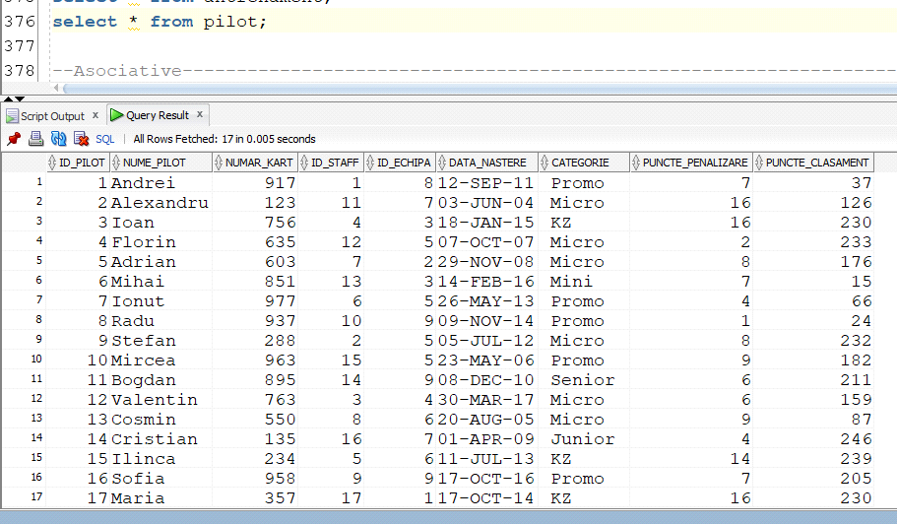

create table jobs

(

id_job number(10) constraint pk_job PRIMARY KEY,

job_name varchar(30),

experienta_necesara number(10),

salariu_mediu number(10)

);

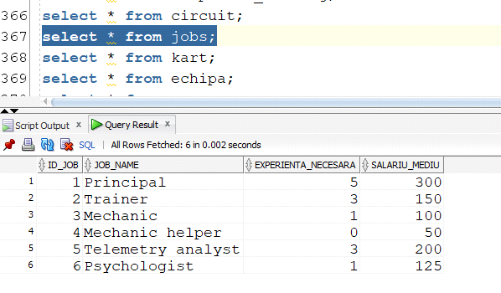

create table ocupa

(

id_staff number(10),

id_job number(10),

data_asignare date,

constraint pk_staff_job_ocupa primary key(id_staff,id_job),

FOREIGN KEY (id_staff) references staff(id_staff),

FOREIGN KEY (id_job) references jobs(id_job)

);

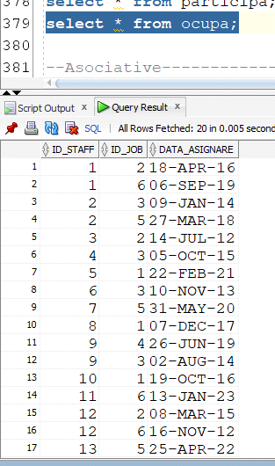

create table participa

(

id_echipa number(10),

id_etapa number(10),

data_inscriere date,

nr_piloti number(10),

constraint pk_echipa_etapa_participa primary key(id_echipa,id_etapa),

FOREIGN KEY (id_etapa) references etapa(id_etapa),

FOREIGN KEY (id_echipa) references echipa(id_echipa)

);

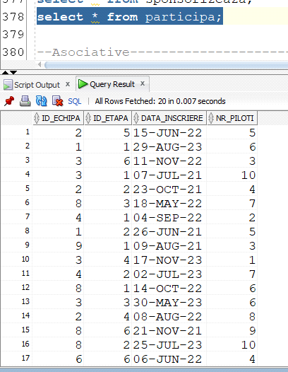

create table sponsorizeaza

(

id_campionat number(10),

id_sponsor number(10),

suma number(10),

data_contract date,

dimensiune_logo number(10),

constraint pk_campionat_sponsor_sponsorizeaza primary key(id_campionat, id_sponsor),

FOREIGN KEY (id_campionat) references campionat_karting(id_campionat),

FOREIGN KEY (id_sponsor) references sponsor(id_sponsor)

);

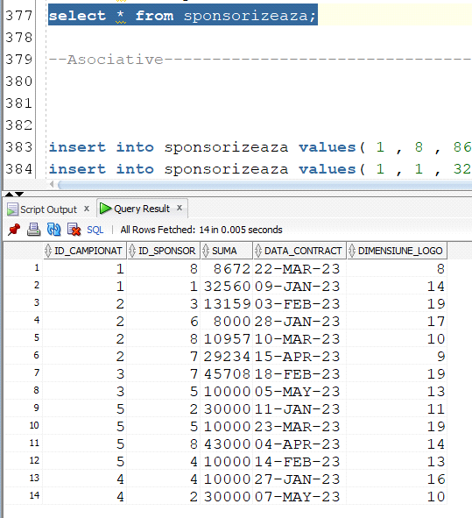

# Inserturi

insert into campionat_karting values(1,'14-APR-2023','28-NOV-2023',6,6,1000000);

insert into campionat_karting values(2,'27-APR-2023','25-OCT-2023',7,9,500000);

insert into campionat_karting values(3,'2-MAY-2023','18-SEP-2023',4,5,200000);

insert into campionat_karting values(4,'4-APR-2023','1-OCT-2023',7,6,400000);

insert into campionat_karting values(5,'15-MAY-2023','23-SEP-2023',5,3,100000);

insert into circuit values(3,'AmcKart',1300,'Bucharest','anti-clockwise',8,350);

insert into circuit values(4,'South Garda',1500,'Lonato','clockwise',11,800);

insert into circuit values(5,'Imola Park',1500,'Imola','clockwise',10,780);

insert into circuit values(6,'SpeedPark',1200,'Bacau','anti-clockwise',7,400);

insert into circuit values(7,'Skat Kart',1500,'Tg. Secuiesc','clockwise',11,1000);

insert into circuit values(8,'Karting Genk',1800,'Genk','clockwise',12,200);

insert into circuit values(9,'Le Mans Karting Circuit',1600,'Le Mans','clockwise',12,920);

insert into circuit values(10,'Circuito Internazionale Napoli',1550,'Sarno','clockwise',10,900);

insert into kart values ( 917 , 55833 , 3461 , 1 );

insert into kart values ( 123 , 47542 , 5530 , 1 );

insert into kart values ( 756 , 48638 , 9719 , 1 );

insert into kart values ( 586 , 31208 , 4409 , 0 );

insert into kart values ( 635 , 98394 , 3510 , 1 );

insert into kart values ( 200 , 48098 , 8768 , 0 );

insert into kart values ( 603 , 59299 , 7472 , 1 );

insert into kart values ( 851 , 17147 , 4508 , 1 );

insert into kart values ( 499 , 75541 , 1696 , 0 );

insert into kart values ( 476 , 69855 , 9268 , 0 );

insert into kart values ( 787 , 30964 , 8533 , 1 );

insert into kart values ( 712 , 49895 , 2665 , 0 );

insert into kart values ( 751 , 85720 , 8275 , 1 );

insert into kart values ( 937 , 68907 , 9932 , 1 );

insert into kart values ( 603 , 63818 , 2534 , 0 );

insert into kart values ( 304 , 51755 , 9390 , 1 );

insert into kart values ( 763 , 30568 , 8831 , 0 );

insert into kart values ( 288 , 41193 , 8523 , 1 );

insert into kart values ( 456 , 69051 , 9787 , 0 );

insert into kart values ( 294 , 41213 , 3789 , 0 );

insert into kart values ( 958 , 65983 , 6970 , 1 );

insert into kart values ( 505 , 28137 , 3601 , 0 );

insert into kart values ( 245 , 93059 , 3377 , 0 );

insert into kart values ( 742 , 61745 , 1596 , 1 );

insert into kart values ( 963 , 69807 , 2673 , 1 );

insert into kart values ( 541 , 38017 , 1461 , 1 );

insert into kart values ( 461 , 63418 , 9146 , 0 );

insert into kart values ( 169 , 65918 , 6059 , 0 );

insert into kart values ( 872 , 42742 , 2023 , 0 );

insert into kart values ( 491 , 82365 , 9260 , 0 );

insert into kart values ( 913 , 89496 , 6846 , 1 );

insert into kart values ( 401 , 26990 , 1566 , 0 );

insert into kart values ( 386 , 87162 , 4086 , 0 );

insert into kart values ( 930 , 75083 , 4048 , 0 );

insert into kart values ( 150 , 74597 , 1880 , 0 );

insert into kart values ( 827 , 18928 , 9898 , 0 );

insert into kart values ( 763 , 72327 , 6652 , 1 );

insert into kart values ( 895 , 71097 , 9282 , 1 );

insert into kart values ( 185 , 16346 , 7126 , 1 );

insert into kart values ( 846 , 59401 , 3833 , 0 );

insert into kart values ( 365 , 65945 , 9782 , 1 );

insert into kart values ( 882 , 92634 , 3989 , 1 );

insert into kart values ( 238 , 71967 , 6811 , 0 );

insert into kart values ( 671 , 38430 , 4928 , 1 );

insert into kart values ( 818 , 33547 , 4739 , 1 );

insert into kart values ( 785 , 35960 , 9028 , 1 );

insert into kart values ( 790 , 73556 , 8003 , 0 );

insert into kart values ( 219 , 31246 , 8799 , 1 );

insert into kart values ( 811 , 53143 , 5620 , 0 );

insert into kart values ( 977 , 93806 , 8363 , 1 );

insert into kart values ( 234 , 76771 , 3740 , 1 );

insert into kart values ( 135 , 68879 , 4667 , 1 );

insert into kart values ( 309 , 17247 , 1075 , 1 );

insert into kart values ( 357 , 76292 , 3180 , 0 );

insert into kart values ( 382 , 95438 , 7328 , 0 );

insert into kart values ( 550 , 78240 , 8846 , 1 );

insert into echipa values ( 1 , 'Autosally' ,'Salistean' ,'12-Sep-2018' , 43351 , 'green' );

insert into echipa values ( 2 , 'Borsch Racing' , 'Borsch' ,'10-Jul-2017' , 85317 , 'yellow' );

insert into echipa values ( 3 , 'Real Racing' ,'Raileanu' ,'20-Apr-2014' , 56597 , 'yellow' );

insert into echipa values ( 4 , 'BRT' ,'Dima' ,'15-Feb-2012' , 36920 , 'yellow' );

insert into echipa values ( 5 , 'JMS Performance' ,'Jacques' ,'03-Mar-2013' , 60554 , 'yellow' );

insert into echipa values ( 6 , 'Grozea Racing' ,'Grozea' ,'23-Jun-2016' , 58606 , 'red' );

insert into echipa values ( 7 , 'Gulstar Racing' ,'Gulie' , '01-Jan-2011' , 68504 , 'red' );

insert into echipa values ( 8 , 'Toka Racing' ,'Dan' , '10-May-2019', 50773 , 'yellow');

insert into echipa values ( 9 , 'Drinago Racing' ,'Boriceanu' ,'29-Sep-2018' , 59752 , 'red' );

insert into sponsor values (1,'Vortex',50000,'Engines');

insert into sponsor values (2,'Levanto',30000,'Tires');

insert into sponsor values (3,'Alpinestars',40000,'Race equipment');

insert into sponsor values (4,'Motul',10000,'Oil');

insert into sponsor values (5,'Porsche Bucuresti Nord',10000,NULL);

insert into sponsor values (6,'Pro Refrigeration',8000,NULL);

insert into sponsor values (7,'Rovere',50000,NULL);

insert into sponsor values (8,'Metropola TV',NULL,'Streaming');

insert into etapa values( 1 ,'19-Apr-2023' ,'21-Apr-2023' , 1 , 8 );

insert into etapa values( 2 ,'01-May-2023' ,'03-May-2023', 1 , 3 );

insert into etapa values( 3 ,'12-May-2023' ,'14-May-2023', 1 , 10 );

insert into etapa values( 4 , '02-Aug-2023', '04-Aug-2023', 1 , 1 );

insert into etapa values( 5 ,'31-Aug-2023' ,'2-Sep-2023' , 1 , 2 );

insert into etapa values( 6 ,'03-Jul-2023' ,'05-Jul-2023' , 1 , 4 );

insert into etapa values( 7 ,'14-May-2023' , '16-May-2023', 2 , 3 );

insert into etapa values( 8 ,'25-Oct-2023' , '27-Oct-2023', 2 , 9 );

insert into etapa values( 9 , '22-Jul-2023', '24-Jul-2023', 2 , 5 );

insert into etapa values( 10 , '02-Aug-2023', '04-Aug-2023', 2 , 6 );

insert into etapa values( 11 , '15-Jun-2023', '15-Jun-2023', 2 , 7 );

insert into etapa values( 12 , '26-Jun-2023', '28-Jun-2023', 2 , 2 );

insert into etapa values( 13 ,'05-Jun-2023' , '07-Jun-2023', 2 , 1 );

insert into etapa values( 14 , '08-Apr-2023', '10-Apr-2023', 3 , 8 );

insert into etapa values( 15 , '24-Sep-2023', '26-Sep-2023', 3 , 6 );

insert into etapa values( 16 , '07-Oct-2023', '09-Oct-2023', 3 , 4 );

insert into etapa values( 17 , '27-May-2023', '29-May-2023', 3 , 7 );

insert into etapa values( 18 , '30-Sep-2023', '2-Oct-2023', 4 , 9 );

insert into etapa values( 19 , '16-Oct-2023', '18-Oct-2023', 4 , 2 );

insert into etapa values( 20 , '22-Jul-2023', '24-Jul-2023', 4 , 1 );

insert into etapa values( 21 , '09-Jul-2023', '11-Jul-2023', 4 , 8 );

insert into etapa values( 22 , '16-Oct-2023', '18-Oct-2023', 4 , 3 );

insert into etapa values( 23 , '02-Aug-2023', '04-Aug-2023', 4 , 5 );

insert into etapa values( 24 , '03-Jul-2023', '05-Jul-2023', 4 , 6 );

insert into etapa values( 25 , '10-Aug-2023', '12-Aug-2023', 5 , 1 );

insert into etapa values( 26 , '09-Jul-2023', '11-Jul-2023', 5 , 8 );

insert into etapa values( 27 , '24-Jun-2023', '26-Jun-2023', 5 , 10 );

insert into etapa values( 28 , '17-Sep-2023', '18-Sep-2023', 5 , 4 );

insert into etapa values( 29 , '15-Oct-2023', '17-Oct-2023', 5 , 5 );

insert into staff values( 1 ,' Benjamin ', 8 , '16-Aug-1995');

insert into staff values( 2 ,' Christopher ', 5 , '05-Jun-1978');

insert into staff values( 3 ,' Daniel ', 4 , '28-Mar-1987');

insert into staff values( 4 ,' Ethan ', 3 , '14-Oct-1999');

insert into staff values( 5 ,' Felix ', 6 , '23-Nov-1991');

insert into staff values( 6 ,' George ', 5 , '09-Feb-1982');

insert into staff values( 7 ,' Henry ', 2 , '19-Apr-1997');

insert into staff values( 8 ,' Isaac ', 6 , '11-Sep-2001');

insert into staff values( 9 ,' Jacob ', 9 , '07-Jul-1993');

insert into staff values( 10 ,' Kevin ', 9 , '26-May-1989');

insert into staff values( 11 ,' Liam ', 7 , '03-Dec-1977');

insert into staff values( 12 ,' Patrick ', 5 , '18-Jan-2002');

insert into staff values( 13 ,' Quentin ', 3 , '30-Jun-1990');

insert into staff values( 14 ,' Thomas ', 9 , '22-Oct-1985');

insert into staff values( 15 ,' Ulysses ', 5 , '12-Mar-1976');

insert into staff values( 16 ,' Victor ', 7 , '26-Apr-2003');

insert into staff values( 17 ,' Bogdan ', 1 , '27-Apr-2003');

insert into cursa values( 1 ,' static ', 12 , 1 );

insert into cursa values( 2 ,' static ', 15 , 15 );

insert into cursa values( 3 ,' static ', 15 , 26 );

insert into cursa values( 4 ,' static ', 6 , 19 );

insert into cursa values( 5 ,' static ', 9 , 9 );

insert into cursa values( 6 ,' motion ', 13 , 1 );

insert into cursa values( 7 ,' static ', 7 , 14 );

insert into cursa values( 8 ,' motion ', 7 , 9 );

insert into cursa values( 9 ,' motion ', 13 , 17 );

insert into cursa values( 10 ,' motion ', 14 , 3 );

insert into cursa values( 11 ,' motion ', 6 , 4 );

insert into cursa values( 12 ,' static ', 8 , 13 );

insert into cursa values( 13 ,' static ', 11 , 26 );

insert into cursa values( 14 ,' motion ', 13 , 21 );

insert into cursa values( 15 ,' static ', 14 , 25 );

insert into cursa values( 16 ,' static ', 7 , 22 );

insert into cursa values( 17 ,' static ', 9 , 23 );

insert into cursa values( 18 ,' motion ', 8 , 4 );

insert into cursa values( 19 ,' motion ', 6 , 3 );

insert into cursa values( 20 ,' static ', 13 , 5 );

insert into calificari values( 1 ,'00:59:482', 12 , 13 );

insert into calificari values( 2 ,'01:03:217', 8 , 28 );

insert into calificari values( 3 ,'00:56:775', 9 , 5 );

insert into calificari values( 4 ,'01:08:934', 12 , 7 );

insert into calificari values( 5 ,'01:01:642', 9 , 11 );

insert into calificari values( 6 ,'01:06:873', 11 , 8 );

insert into calificari values( 7 ,'01:02:311', 9 , 1 );

insert into calificari values( 8 ,'01:04:568', 8 , 28 );

insert into calificari values( 9 ,'01:07:189', 9 , 25 );

insert into calificari values( 10 ,'01:00:912', 8 , 17 );

insert into antrenament values( 1 ,' liber ', 12 , 17 );

insert into antrenament values( 2 ,' eliminatoriu ', 12 , 27 );

insert into antrenament values( 3 ,' calificativ ', 12 , 29 );

insert into antrenament values( 4 ,' liber ', 11 , 6 );

insert into antrenament values( 5 ,' calificativ ', 8 , 14 );

insert into antrenament values( 6 ,' eliminatoriu ', 9 , 28 );

insert into antrenament values( 7 ,' liber ', 10 , 21 );

insert into antrenament values( 8 ,' liber ', 10 , 16 );

insert into antrenament values( 9 ,' calificativ ', 12 , 18 );

insert into antrenament values( 10 ,' eliminatoriu ', 10);

insert into pilot values( 1 , 'Andrei' , 917, 1 , '12-Sep-2011' ,' Promo ', 7 ,37);

insert into pilot values( 2 , 'Alexandru' ,123, 11 , '03-Jun-2004' ,' Micro ', 16, 126);

insert into pilot values( 3 , 'Ioan' , 756, 4 , '18-Jan-2015' ,' KZ ', 16 ,230);

insert into pilot values( 4 , 'Florin' , 635, 12 , '07-Oct-2007' ,' Micro ', 2, 233);

insert into pilot values( 5 , 'Adrian' , 603, 7 , '29-Nov-2008' ,' Micro ', 8, 176);

insert into pilot values( 6 , 'Mihai' , 851, 13 , '14-Feb-2016' ,' Mini ', 7, 15);

insert into pilot values( 7 , 'Ionut' , 977, 6 , '26-May-2013' ,' Promo ', 4, 66);

insert into pilot values( 8 , 'Radu' , 937, 10, '09-Nov-2014' ,' Promo ', 1, 24);

insert into pilot values( 9 , 'Stefan' , 288, 2 , '05-Jul-2012' ,' Micro ', 8 ,232);

insert into pilot values( 10 , 'Mircea' , 963, 15 , '23-May-2006' ,' Promo ', 9, 182);

insert into pilot values( 11 , 'Bogdan' , 895, 14 , '08-Dec-2010' ,' Senior ', 6, 211);

insert into pilot values( 12 , 'Valentin' ,763, 3 , '30-Mar-2017' ,' Micro ', 6 ,159);

insert into pilot values( 13 , 'Cosmin' , 550, 8 , '20-Aug-2005' ,' Micro ', 9 ,87);

insert into pilot values( 14 , 'Cristian' ,135, 16 , '01-Apr-2009' ,' Junior ', 4, 246);

insert into pilot values( 15 , 'Ilinca' , 234, 5 , '11-Jul-2013' ,' KZ ', 14 ,239);

insert into pilot values( 16 , 'Sofia' , 958, 9, '17-Oct-2016' ,' Promo ', 7, 205);

insert into pilot values( 17 , 'Maria' , 357, 17,'17-Oct-2014' ,' KZ ', 16, 230);

insert into sponsorizeaza values( 1 , 8 , 8672 ,'22-Mar-2023', 8 );

insert into sponsorizeaza values( 1 , 1 , 32560 ,'9-Jan-2023', 14 );

insert into sponsorizeaza values( 2 , 3 , 13159 ,'3-Feb-2023', 19 );

insert into sponsorizeaza values( 2 , 6 , 20668 ,'28-Jan-2023', 17 );

insert into sponsorizeaza values( 2 , 8 , 10957 ,'10-Mar-2023', 10 );

insert into sponsorizeaza values( 2 , 7 , 29234 ,'15-Apr-2023', 9 );

insert into sponsorizeaza values( 3 , 7 , 45708 ,'18-Feb-2023', 19 );

insert into sponsorizeaza values( 3 , 5 , 38658 ,'5-May-2023', 13 );

insert into sponsorizeaza values( 5 , 2 , 33402 ,'11-Jan-2023', 11 );

insert into sponsorizeaza values( 5 , 5 , 12367 ,'23-Mar-2023', 19 );

insert into sponsorizeaza values( 5 , 8 , 43000 ,'4-Apr-2023', 14 );

insert into sponsorizeaza values( 5 , 4 , 10600 ,'14-Feb-2023', 13 );

insert into sponsorizeaza values( 4 , 4 , 26520 ,'27-Jan-2023', 16 );

insert into sponsorizeaza values( 4 , 2 , 45772 ,'7-May-2023', 10 );

insert into ocupa values( 1 , 2 ,'18-Apr-2016');

insert into ocupa values( 1 , 6 ,'06-Sep-2019');

insert into ocupa values( 2 , 3 ,'09-Jan-2014');

insert into ocupa values( 2 , 5 ,'27-Mar-2018');

insert into ocupa values( 3 , 2 ,'14-Jul-2012');

insert into ocupa values( 4 , 3 ,'05-Oct-2015');

insert into ocupa values( 5 , 1 ,'22-Feb-2021');

insert into ocupa values( 6 , 3 ,'10-Nov-2013');

insert into ocupa values( 7 , 5 ,'31-May-2020');

insert into ocupa values( 8 , 1 ,'07-Dec-2017');

insert into ocupa values( 9 , 4 ,'26-Jun-2019');

insert into ocupa values( 9 , 3 ,'02-Aug-2014');

insert into ocupa values( 10 , 1 ,'19-Oct-2016');

insert into ocupa values( 11 , 6 ,'13-Jan-2023');

insert into ocupa values( 12 , 2 ,'08-Mar-2015');

insert into ocupa values( 12 , 6 ,'16-Nov-2012');

insert into ocupa values( 13 , 5 ,'25-Apr-2022');

insert into ocupa values( 14 , 4 ,'11-Sep-2018');

insert into ocupa values( 15 , 4 ,'30-Jul-2021');

insert into ocupa values( 16 , 2 ,'04-Feb-2017');

insert into participa values( 2 , 5 ,'15-Jun-2022',5);

insert into participa values( 1 , 1 ,'29-Aug-2023',6);

insert into participa values( 3 , 6 ,'11-Nov-2022',3);

insert into participa values( 3 , 1 ,'07-Jul-2021',10);

insert into participa values( 2 , 2 ,'23-Oct-2021',4);

insert into participa values( 8 , 3 ,'18-May-2022',7);

insert into participa values( 4 , 1 ,'04-Sep-2022',2);

insert into participa values( 1 , 2 ,'26-Jun-2021',5);

insert into participa values( 9 , 1 ,'09-Aug-2021',3);

insert into participa values( 3 , 4 ,'17-Nov-2023',1);

insert into participa values( 4 , 2 ,'02-Jul-2023',7);

insert into participa values( 8 , 1 ,'14-Oct-2022',6);

insert into participa values( 3 , 3 ,'30-May-2023',6);

insert into participa values( 2 , 4 ,'08-Aug-2022',8);

insert into participa values( 8 , 6 ,'21-Nov-2021',9);

insert into participa values( 8 , 2 ,'25-Jul-2023',10);

insert into participa values( 6 , 6 ,'06-Jun-2022',4);

insert into participa values( 6 , 2 ,'12-Oct-2021',6);

insert into participa values( 7 , 6 ,'01-Sep-2023',9);

insert into participa values( 5 , 1 ,'19-May-2021',2);

insert into participa values( 5 , 7 ,'18-May-2021',4);

insert into participa values( 6 , 11 ,'13-Oct-2021',5);

insert into participa values( 4 , 19 ,'02-Jul-2023',7);

insert into jobs values(1,'Principal',5,300);

insert into jobs values(2,'Trainer',3,150);

insert into jobs values(3,'Mechanic',1,100);

insert into jobs values(4,'Mechanic helper',0,50);

insert into jobs values(5,'Telemetry analyst',3,200);

insert into jobs values(6,'Psychologist',1,125);

# Subprogram cu 3 colectii

**--**Subprogramul afiseaza etapele cu numar impar si echipele care au participat la acestea, impreuna cu numarul total de ture parcurs pentru fiecare etapa. (tabel indexat -> numere impare, tabel imbricate -> echipe, vector -> cursele)

create or replace procedure ex6 as

type tabel_index is table of number index by pls_integer;

type tabel_echipe is table of varchar2(100);

type array_ture is varray(100) of number;

etape tabel_index;

echipe tabel_echipe := tabel_echipe();

ture array_ture := array_ture();

v_ture number;

cursor iduri is

SELECT id_etapa

FROM etapa

WHERE mod(id_etapa,2) = 1;

begin

for etapa in iduri loop

etape(etape.count + 1) := etapa.id_etapa;

end loop;

for i in 1..etape.count loop

for ec in

(select nume_echipa

from echipa e, participa p

where e.id_echipa = p.id_echipa

and p.id_etapa = etape(i)

and p.nr_piloti >= 0)

loop

echipe.extend;

echipe(echipe.last) := ec.nume_echipa;

end loop;

for nr_ture in

(select numar_total_ture

from cursa

where id_etapa = etape(i))

loop

ture.extend;

ture(ture.last) := nr_ture.numar_total_ture;

end loop;

if echipe.count > 0 then

DBMS_output.put('La etapa ' || etape(i) || ' au participat echipele: ');

for i in 1..echipe.count loop

DBMS_output.put(echipe(i) || ' - ');

end loop;

v_ture := 0;

for i in 1..ture.count loop

v_ture := v_ture + ture(i);

end loop;

dbms_output.put_line('si au parcurs ' || v_ture || ' ture de circuit');

end if;

ture.delete;

echipe.delete;

end loop;

end;

/

execute ex6;

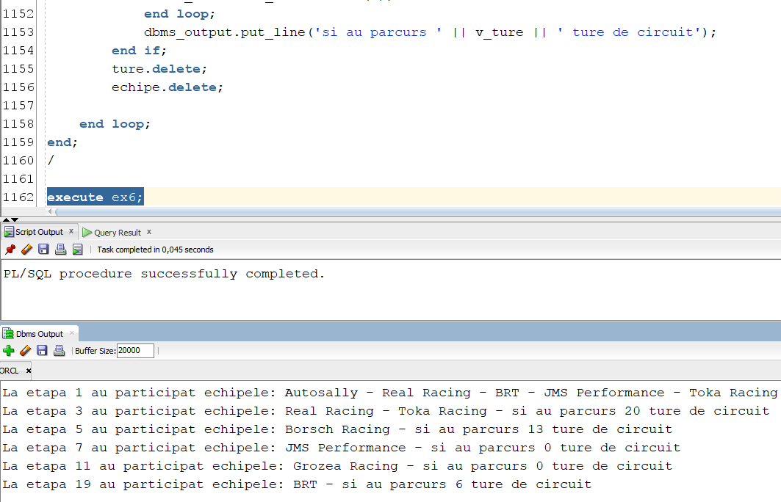

# 

# 2 Cursoare

CREATE OR REPLACE PROCEDURE ex7 AS

TYPE refcursor is ref cursor;

angajati refcursor;

v_culoare echipa.main_color%TYPE := 'yellow';

v_echipa echipa.nume_echipa%TYPE;

v_staff staff.nume_staff%type;

CURSOR ec(culoare VARCHAR2) IS

SELECT e.nume_echipa,

CURSOR (

SELECT s.nume_staff

FROM staff s

WHERE s.id_echipa = e.id_echipa

)

FROM echipa e

WHERE e.main_color = culoare;

BEGIN

OPEN ec(v_culoare);

LOOP

FETCH ec into v_echipa,angajati;

EXIT WHEN ec%NOTFOUND;

DBMS_OUTPUT.PUT('Echipa ' || v_echipa || ' este formata din: ');

LOOP

fetch angajati into v_staff;

exit when angajati%notfound;

DBMS_OUTPUT.PUT(v_staff || ' ');

END LOOP;

DBMS_OUTPUT.PUT_LINE('');

END LOOP;

CLOSE ec;

END;

/

execute ex7;

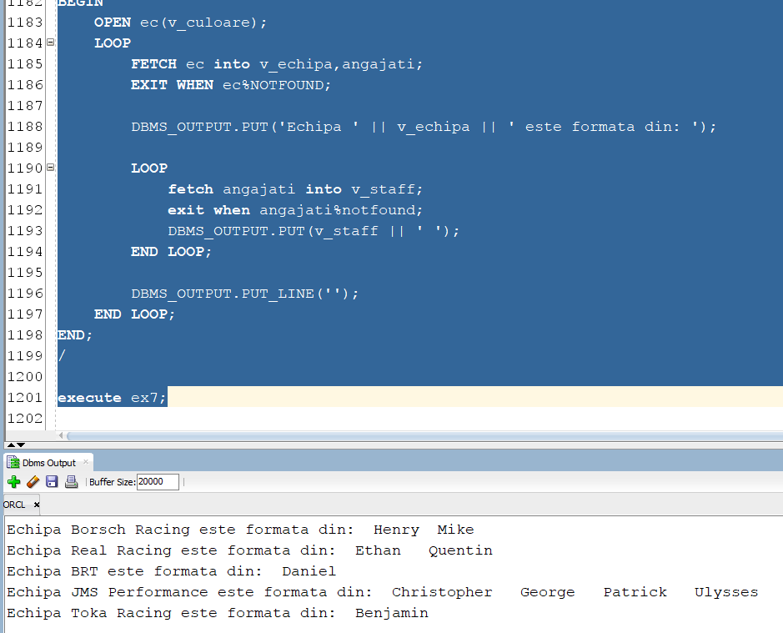

# Minim 3 tabele (pilot + staff + participa + etapa)

--problema returneaza ‘da’ sau ‘ nu + “eroarea” ’ daca datele pentru o anumita etapa sunt incorecte (data etapei este gresita sau exista o echipa ce a inscris mai multi piloti decat are). De asemenea un pilot este valid daca acesta are un kart principal atribuit.

create or replace function ex8 return varchar2 is

type tabel_nr_piloti is table of varchar2(100);

wrong_date exception;

bad_register exception;

nr_piloti tabel_nr_piloti := tabel_nr_piloti();

v_echipa echipa.id_echipa%type;

v_etapa etapa.id_etapa%type;

data_inc etapa.data_inceput%type;

data_fin etapa.data_final%type;

nr_p number;

cursor ec is

select id_echipa,count(p.id_pilot)

from pilot p, staff s, kart k

where p.id_staff = s.id_staff

and k.numar_kart = p.numar_kart

and k.main_kart = 1

group by id_echipa

order by 1;

cursor et is

select id_etapa, data_inceput, data_final

from etapa;

begin

for i in (select id_echipa from echipa) loop

nr_piloti.extend;

end loop;

open ec;

loop

fetch ec into v_echipa, nr_p;

exit when ec%notfound;

nr_piloti(v_echipa) := nr_p;

end loop;

close ec;

open et;

loop

fetch et into v_etapa, data_inc, data_fin;

exit when et%notfound;

if data_inc > data_fin then

raise wrong_date;

end if;

end loop;

close et;

for round in (select id_etapa from etapa) loop

for i in 1..nr_piloti.count loop

select nr_piloti

into nr_p

from participa

where id_etapa = round.id_etapa

and id_echipa = i;

if nr_p > nr_piloti(i) then

raise bad_register;

end if;

end loop;

end loop;

return 'da';

exception

when wrong_date then

return 'no, invalid date';

when bad_register then

return 'no, bad team register';

end ex8;

/

select ex8 from dual;

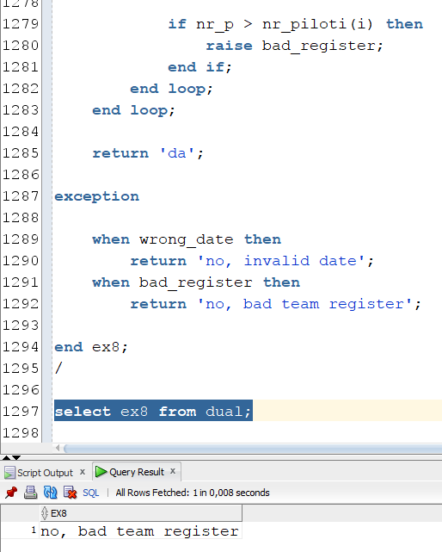

# Minim 5 tabele

--(sponsorizeaza, campionat_karting,etapa,circuit,participa)

Cererea calculeaza pentru fiecare etapa suma de bani primita de la sponsori adunata la bugetul campionatului. Pentru fiecare etapa din cadrul unui campionat se calculeaza costul impus de circuit(, 5 * lungime * latimea maxima). De asemenea, este calculat si venitul produs din inscrierea pilotilor la acea etapa(400* numarul total de piloti). La final se calculeaza profitul prin diferenta dintre bugetul total si cheltuielile totale.

create or replace procedure ex9 as

TYPE t_result IS RECORD (

id_campionat NUMBER,

tbuget NUMBER,

cost_total NUMBER,

profit NUMBER

);

TYPE t_matrix IS TABLE OF t_result;

v_results t_matrix;

nr_campionate number;

NO_DATA_FOUND exception;

TOO_MANY_ROWS exception;

even exception;

loss exception;

cursor profitCampionat is

select bu.id_campionat,tbuget,cost_total,tbuget-cost_total as profit

from (select s.id_campionat,sum(s.suma)+ k.buget as tbuget

from sponsorizeaza s, campionat_karting k

where k.id_campionat = s.id_campionat

group by s.id_campionat,k.buget) bu,

(select id_campionat,sum(cost_etapa) as cost_total

from (select e.id_campionat,e.id_etapa,tcost-tnrp as cost_etapa

from etapa e,(select id_circuit, 5 * lungime * latime_max as tcost

from circuit) c,(select id_etapa, 400*sum(nr_piloti) as tnrp

from participa

group by id_etapa) p

where e.id_circuit = c.id_circuit

and p.id_etapa = e.id_etapa)

group by id_campionat) co

where co.id_campionat = bu.id_campionat

order by 1;

begin

select count(*)

into nr_campionate

from campionat_karting;

OPEN profitCampionat;

FETCH profitCampionat BULK COLLECT INTO v_results;

CLOSE profitCampionat;

IF v_results.COUNT = 0 THEN

raise no_data_found;

elsif v_results.count > nr_campionate then

raise too_many_rows;

else

FOR i IN v_results.FIRST .. v_results.LAST LOOP

if v_results(i).profit = 0 then

dbms_output.put('ID_CAMPIONAT: ' || v_results(i).id_campionat || ' ');

raise even;

elsif v_results(i).profit < 0 then

dbms_output.put('ID_CAMPIONAT: ' || v_results(i).id_campionat || ' ');

raise loss;

end if;

DBMS_OUTPUT.PUT_LINE(

'ID_CAMPIONAT: ' || v_results(i).id_campionat ||

' | TOTAL_BUGET: ' || v_results(i).tbuget ||

' | COST_TOTAL: ' || v_results(i).cost_total ||

' | PROFIT: ' || v_results(i).profit

);

END LOOP;

end if;

EXCEPTION

WHEN NO_DATA_FOUND THEN

DBMS_OUTPUT.PUT_LINE('Nu s-au găsit date.');

WHEN TOO_MANY_ROWS THEN

DBMS_OUTPUT.PUT_LINE('Prea multe înregistrări găsite.');

when even then

dbms_output.put_line('Campionatul nu a produs profit');

when loss then

dbms_output.put_line('Campionatul este in pierdere');

WHEN OTHERS THEN

DBMS_OUTPUT.PUT_LINE('O eroare a apărut: ' || SQLERRM);

END ex9;

/

insert into campionat_karting values(7,'3-01-2024','26-09-2024',3,3,0);

insert into etapa values( 30 , '02-02-2024', '04-02-2024', 7 , 1 );

insert into participa values( 1 , 30 ,'01-02-2024',1);

insert into sponsorizeaza values( 7 , 1 , 0 ,'02-01-2024', 10 );

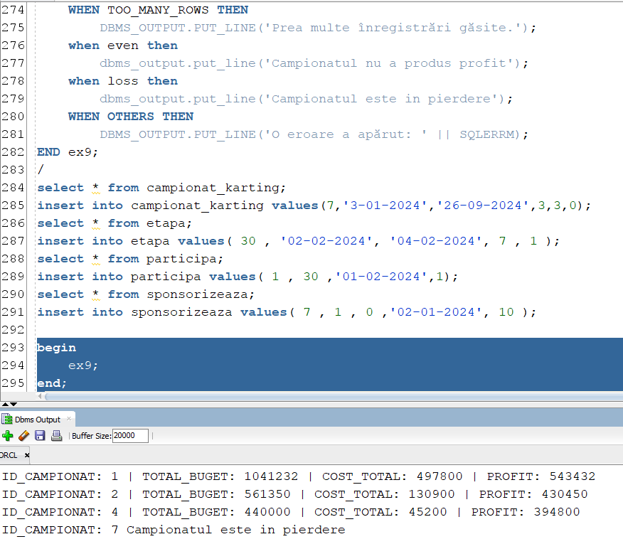

# Minim 5 tabele (v2)

Procedura afiseaza directorii de echipa care sunt inregistrati ca angajati de tipul ‘principal’, impreuna cu pilotul pe care il antreneaza.

create or replace procedure ex9_v2 as

TYPE t_result IS RECORD (

nume_director varchar2(100),

nume_staff varchar2(100),

nume_echipa varchar2(100),

nume_pilot varchar2(100)

);

TYPE t_matrix IS TABLE OF t_result;

v_results t_matrix;

nr_staff number;

wrong_name exception;

cursor director is

select e.nume_director,s.nume_staff,e.nume_echipa , p.nume_pilot

from echipa e, staff s, ocupa o, jobs j, pilot p

where s.id_echipa = e.id_echipa

and s.id_staff = o.id_staff

and o.id_job = j.id_job

and trim(lower(job_name)) = 'principal'

and s.id_staff = p.id_staff;

begin

select count(*)

into nr_staff

from staff;

OPEN director;

FETCH director BULK COLLECT INTO v_results;

CLOSE director;

IF v_results.COUNT = 0 THEN

raise no_data_found;

elsif v_results.count > nr_staff then

raise too_many_rows;

else

FOR i IN v_results.FIRST .. v_results.LAST LOOP

if v_results(i).nume_director <> v_results(i).nume_staff then

raise wrong_name;

end if;

dbms_output.put_line('Nume director: '|| v_results(i).nume_director ||

', nume echipa: '|| v_results(i).nume_echipa ||

', nume pilot: '|| v_results(i).nume_pilot);

END LOOP;

end if;

EXCEPTION

WHEN NO_DATA_FOUND THEN

DBMS_OUTPUT.PUT_LINE('Nu s-au găsit date.');

WHEN TOO_MANY_ROWS THEN

DBMS_OUTPUT.PUT_LINE('Prea multe înregistrări găsite.');

When wrong_name then

dbms_output.put_line('Numele staffului e diferit de numele directorului');

WHEN OTHERS THEN

DBMS_OUTPUT.PUT_LINE('O eroare a apărut: ' || SQLERRM);

end ex9_v2;

/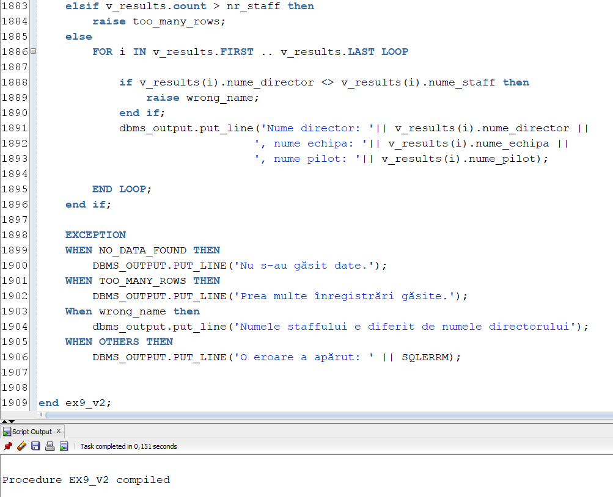

--dupa inserare:

insert into staff values( 21 ,'Boriceanu', 9 , '27-Apr-2003');

insert into pilot values( 20 , 'Dani' , null , 21,'17-Oct-2015' ,' Senior ', 7, 130);

insert into ocupa values( 21 , 1 ,'02-Aug-2016');

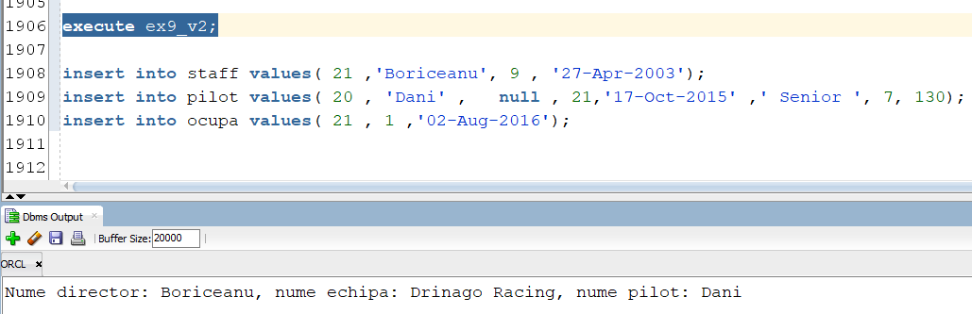

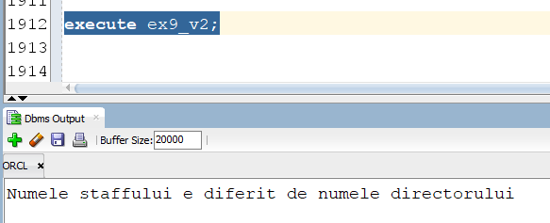

# Trigger LMD la nivel de comanda

Triggerul nu permite inscrierea a mai mult de 9 echipe la nivel national.

CREATE OR REPLACE TRIGGER nr_max_echipe

BEFORE INSERT ON echipa

DECLARE

v_nr_echipe number(2);

BEGIN

select count(*)

into v_nr_echipe

from echipa;

if v_nr_echipe >= 9 then

RAISE_APPLICATION_ERROR(-20001,'A fost atins numarul maxim de echipe ce se pot inscrie');

end if;

end;

/

insert into echipa values(10, 'Cube Racing', 'Tomi', '05-01-2022',45000,'blue'); 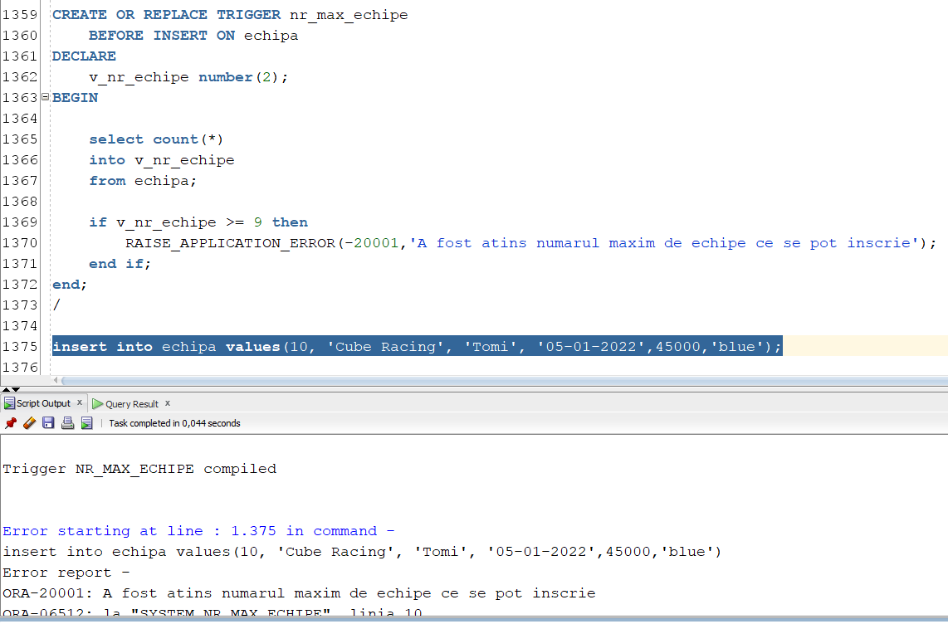

# Trigger LMD la nivel de linie

Triggerul nu permite inserarea a mai mult de 3 piloti in cadrul aceleiasi categorii.

create or replace trigger limita_categorie

before insert on pilot

for each row

declare

v_nr number;

v_categorie varchar2(100);

begin

v_categorie := TRIM(LOWER(:new.categorie));

select count(*)

into v_nr

from pilot

where trim(lower(categorie)) = v_categorie;

if v_nr >= 3 then

RAISE_APPLICATION_ERROR(-20001, 'Nu se permite inserarea a mai mult de 3 piloti la aceeasi cagtegorie');

end if;

end limita_categorie;

/

insert into pilot values (20, 'Toby', NULL, 18, '26-08-2009', 'KZ', 4, 201); 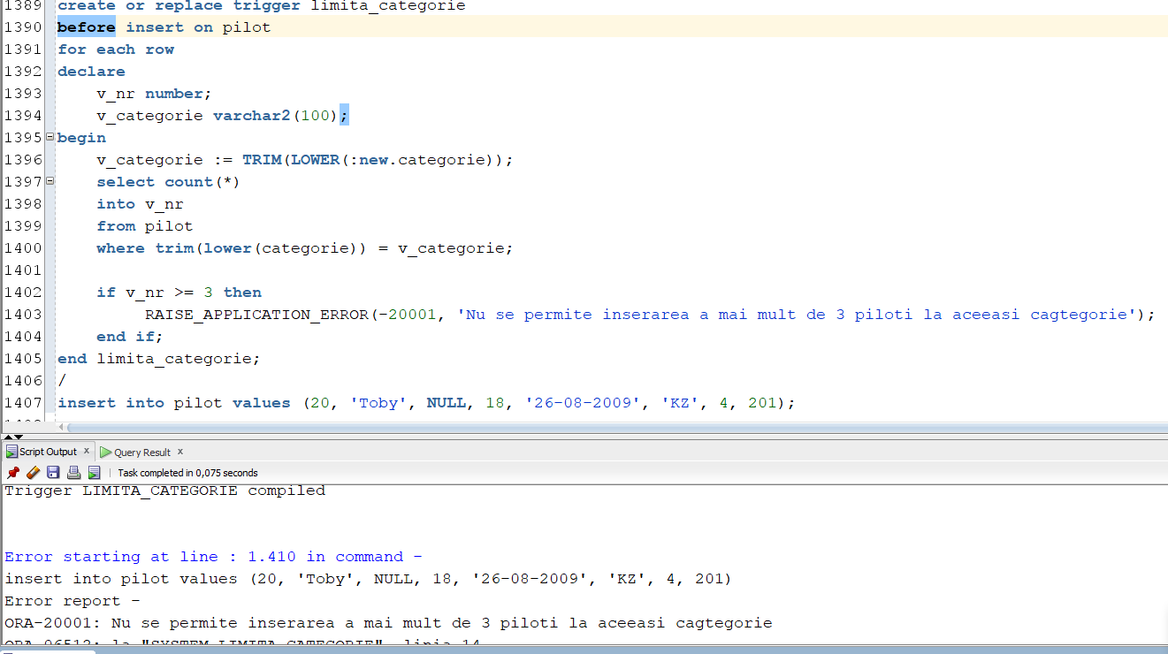

# Trigger LDD

Triggerul nu permite stergerea sau alterarea unei tabele atunci cand este activ.

CREATE OR REPLACE TRIGGER safety

BEFORE DROP OR ALTER ON DATABASE

DECLARE

BEGIN

DBMS_OUTPUT.PUT_LINE('Triggerul de securitate este activat. Dezactiva-ti-l pentru a realiza operatiile dorite!');

RAISE_APPLICATION_ERROR(-20001, 'Trigger safety activ');

END safety;

/

alter trigger safety enable;

drop table pilot; 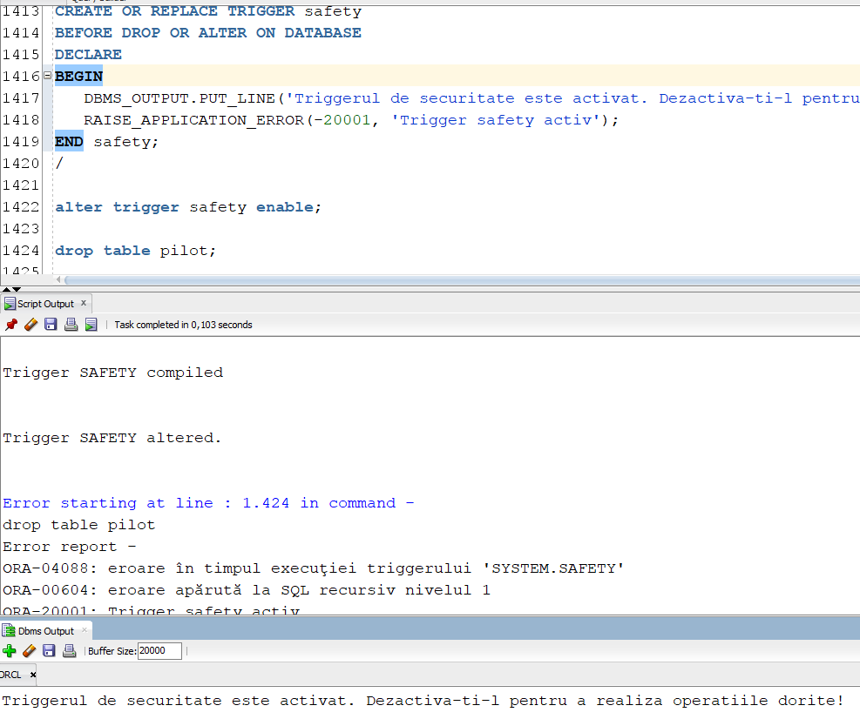

# Pachet cu toate obiectele proiectului

create or replace package pachet_karting as

--ex6

procedure ex6;

--ex7

procedure ex7;

--ex8

function ex8 return varchar2;

--ex9

procedure ex9;

procedure ex9_v2;

end pachet_karting;

--#################################################

create or replace package body pachet_karting as

----------------------------------------------------------------------------------------------------------------

--ex6-----------------------------------------------------------------------------------------------------------

----------------------------------------------------------------------------------------------------------------

procedure ex6 as

type tabel_index is table of number index by pls_integer;

type tabel_echipe is table of varchar2(100);

type array_ture is varray(100) of number;

etape tabel_index;

echipe tabel_echipe := tabel_echipe();

ture array_ture := array_ture();

v_ture number;

cursor iduri is

SELECT id_etapa

FROM etapa

WHERE mod(id_etapa,2) = 1;

begin

for etapa in iduri loop

etape(etape.count + 1) := etapa.id_etapa;

end loop;

for i in 1..etape.count loop

for ec in

(select nume_echipa

from echipa e, participa p

where e.id_echipa = p.id_echipa

and p.id_etapa = etape(i)

and p.nr_piloti >= 0)

loop

echipe.extend;

echipe(echipe.last) := ec.nume_echipa;

end loop;

for nr_ture in

(select numar_total_ture

from cursa

where id_etapa = etape(i))

loop

ture.extend;

ture(ture.last) := nr_ture.numar_total_ture;

end loop;

if echipe.count > 0 then

DBMS_output.put('La etapa ' || etape(i) || ' au participat echipele: ');

for i in 1..echipe.count loop

DBMS_output.put(echipe(i) || ' - ');

end loop;

v_ture := 0;

for i in 1..ture.count loop

v_ture := v_ture + ture(i);

end loop;

dbms_output.put_line('si au parcurs ' || v_ture || ' ture de circuit');

end if;

ture.delete;

echipe.delete;

end loop;

end ex6;

----------------------------------------------------------------------------------------------------------------

--Ex7-----------------------------------------------------------------------------------------------------------

----------------------------------------------------------------------------------------------------------------

PROCEDURE ex7 AS

TYPE refcursor is ref cursor;

angajati refcursor;

v_culoare echipa.main_color%TYPE := 'yellow';

v_echipa echipa.nume_echipa%TYPE;

v_staff staff.nume_staff%type;

CURSOR ec(culoare VARCHAR2) IS

SELECT e.nume_echipa,

CURSOR (

SELECT s.nume_staff

FROM staff s

WHERE s.id_echipa = e.id_echipa

)

FROM echipa e

WHERE e.main_color = culoare;

BEGIN

OPEN ec(v_culoare);

LOOP

FETCH ec into v_echipa,angajati;

EXIT WHEN ec%NOTFOUND;

DBMS_OUTPUT.PUT('Echipa ' || v_echipa || ' este formata din: ');

LOOP

fetch angajati into v_staff;

exit when angajati%notfound;

DBMS_OUTPUT.PUT(v_staff || ' ');

END LOOP;

DBMS_OUTPUT.PUT_LINE('');

END LOOP;

CLOSE ec;

END ex7;

----------------------------------------------------------------------------------------------------------------

--ex8-----------------------------------------------------------------------------------------------------------

----------------------------------------------------------------------------------------------------------------

function ex8 return varchar2 is

type tabel_nr_piloti is table of varchar2(100);

wrong_date exception;

bad_register exception;

nr_piloti tabel_nr_piloti := tabel_nr_piloti();

v_echipa echipa.id_echipa%type;

v_etapa etapa.id_etapa%type;

data_inc etapa.data_inceput%type;

data_fin etapa.data_final%type;

nr_p number;

cursor ec is

select id_echipa,count(p.id_pilot)

from pilot p, staff s, kart k

where p.id_staff = s.id_staff

and k.numar_kart = p.numar_kart

and k.main_kart = 1

group by id_echipa

order by 1;

cursor et is

select id_etapa, data_inceput, data_final

from etapa;

begin

for i in (select id_echipa from echipa) loop

nr_piloti.extend;

end loop;

open ec;

loop

fetch ec into v_echipa, nr_p;

exit when ec%notfound;

nr_piloti(v_echipa) := nr_p;

end loop;

close ec;

open et;

loop

fetch et into v_etapa, data_inc, data_fin;

exit when et%notfound;

if data_inc > data_fin then

raise wrong_date;

end if;

end loop;

close et;

for round in (select id_etapa from etapa) loop

for i in 1..nr_piloti.count loop

select nr_piloti

into nr_p

from participa

where id_etapa = round.id_etapa

and id_echipa = i;

if nr_p > nr_piloti(i) then

raise bad_register;

end if;

end loop;

end loop;

return 'da';

exception

when wrong_date then

return 'no, invalid date';

when bad_register then

return 'no, bad team register';

end ex8;

----------------------------------------------------------------------------------------------------------------

--ex9-----------------------------------------------------------------------------------------------------------

----------------------------------------------------------------------------------------------------------------

procedure ex9 as

TYPE t_result IS RECORD (

id_campionat NUMBER,

tbuget NUMBER,

cost_total NUMBER,

profit NUMBER

);

TYPE t_matrix IS TABLE OF t_result;

v_results t_matrix;

nr_campionate number;

NO_DATA_FOUND exception;

TOO_MANY_ROWS exception;

even exception;

loss exception;

cursor profitCampionat is

select bu.id_campionat,tbuget,cost_total,tbuget-cost_total as profit

from (select s.id_campionat,sum(s.suma)+ k.buget as tbuget

from sponsorizeaza s, campionat_karting k

where k.id_campionat = s.id_campionat

group by s.id_campionat,k.buget) bu,

(select id_campionat,sum(cost_etapa) as cost_total

from (select e.id_campionat,e.id_etapa,tcost-tnrp as cost_etapa

from etapa e,(select id_circuit, 5 * lungime * latime_max as tcost

from circuit) c,(select id_etapa, 400*sum(nr_piloti) as tnrp

from participa

group by id_etapa) p

where e.id_circuit = c.id_circuit

and p.id_etapa = e.id_etapa)

group by id_campionat) co

where co.id_campionat = bu.id_campionat

order by 1;

begin

select count(*)

into nr_campionate

from campionat_karting;

OPEN profitCampionat;

FETCH profitCampionat BULK COLLECT INTO v_results;

CLOSE profitCampionat;

IF v_results.COUNT = 0 THEN

raise no_data_found;

elsif v_results.count > nr_campionate then

raise too_many_rows;

else

FOR i IN v_results.FIRST .. v_results.LAST LOOP

if v_results(i).profit = 0 then

dbms_output.put('ID_CAMPIONAT: ' || v_results(i).id_campionat || ' ');

raise even;

elsif v_results(i).profit < 0 then

dbms_output.put('ID_CAMPIONAT: ' || v_results(i).id_campionat || ' ');

raise loss;

end if;

DBMS_OUTPUT.PUT_LINE(

'ID_CAMPIONAT: ' || v_results(i).id_campionat ||

' | TOTAL_BUGET: ' || v_results(i).tbuget ||

' | COST_TOTAL: ' || v_results(i).cost_total ||

' | PROFIT: ' || v_results(i).profit

);

END LOOP;

end if;

EXCEPTION

WHEN NO_DATA_FOUND THEN

DBMS_OUTPUT.PUT_LINE('Nu s-au găsit date.');

WHEN TOO_MANY_ROWS THEN

DBMS_OUTPUT.PUT_LINE('Prea multe înregistrări găsite.');

when even then

dbms_output.put_line('Campionatul nu a produs profit');

when loss then

dbms_output.put_line('Campionatul este in pierdere');

WHEN OTHERS THEN

DBMS_OUTPUT.PUT_LINE('O eroare a apărut: ' || SQLERRM);

END ex9;

----------------------------------------------------------------------------------------------------------------

--v2------------------------------------------------------------------------------------------------------------

----------------------------------------------------------------------------------------------------------------

procedure ex9_v2 as

TYPE t_result IS RECORD (

nume_director varchar2(100),

nume_staff varchar2(100),

nume_echipa varchar2(100),

nume_pilot varchar2(100)

);

TYPE t_matrix IS TABLE OF t_result;

v_results t_matrix;

nr_staff number;

wrong_name exception;

cursor director is

select e.nume_director,s.nume_staff,e.nume_echipa , p.nume_pilot

from echipa e, staff s, ocupa o, jobs j, pilot p

where s.id_echipa = e.id_echipa

and s.id_staff = o.id_staff

and o.id_job = j.id_job

and trim(lower(job_name)) = 'principal'

and s.id_staff = p.id_staff;

begin

select count(*)

into nr_staff

from staff;

OPEN director;

FETCH director BULK COLLECT INTO v_results;

CLOSE director;

IF v_results.COUNT = 0 THEN

raise no_data_found;

elsif v_results.count > nr_staff then

raise too_many_rows;

else

FOR i IN v_results.FIRST .. v_results.LAST LOOP

if v_results(i).nume_director <> v_results(i).nume_staff then

raise wrong_name;

end if;

dbms_output.put_line('Nume director: '|| v_results(i).nume_director ||

', nume echipa: '|| v_results(i).nume_echipa ||

', nume pilot: '|| v_results(i).nume_pilot);

END LOOP;

end if;

EXCEPTION

WHEN NO_DATA_FOUND THEN

DBMS_OUTPUT.PUT_LINE('Nu s-au găsit date.');

WHEN TOO_MANY_ROWS THEN

DBMS_OUTPUT.PUT_LINE('Prea multe înregistrări găsite.');

When wrong_name then

dbms_output.put_line('Numele staffului e diferit de numele directorului');

WHEN OTHERS THEN

DBMS_OUTPUT.PUT_LINE('O eroare a apărut: ' || SQLERRM);

end ex9_v2;

end pachet_karting;

/

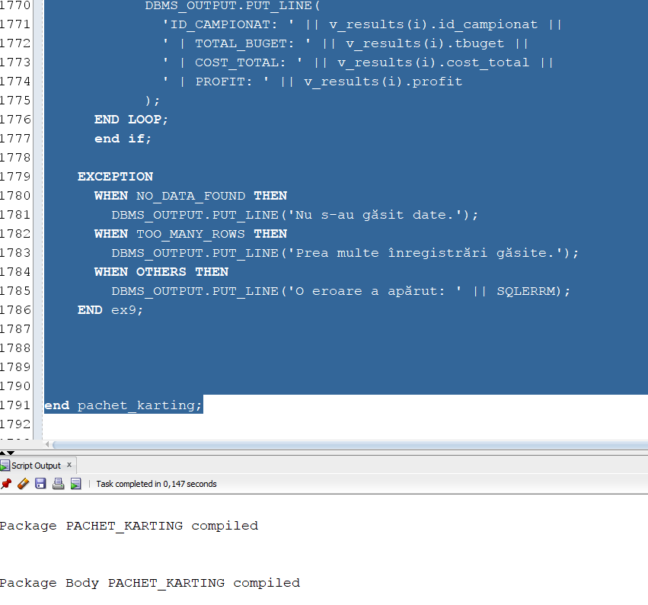

## 3 Coletii

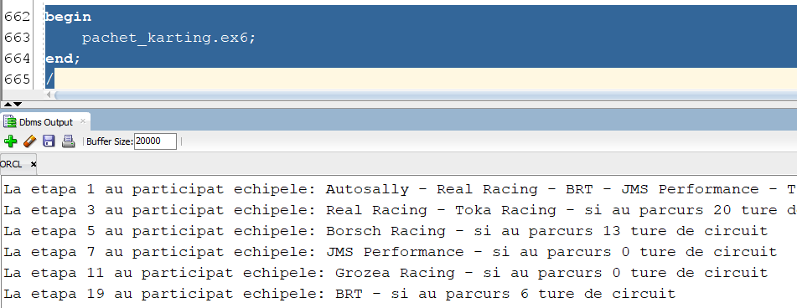

## 2 Cursoare

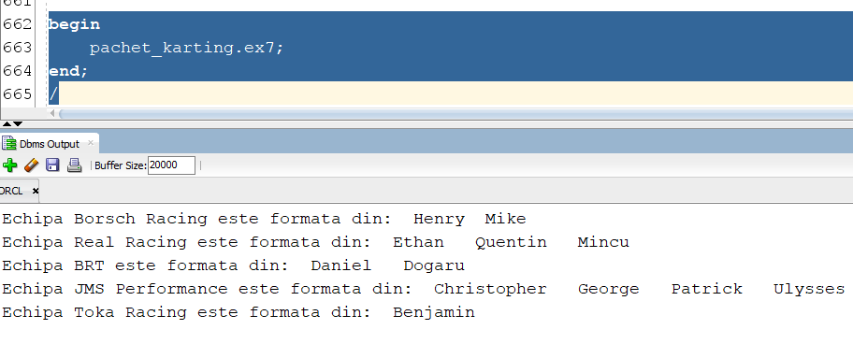

## 3 Tabele

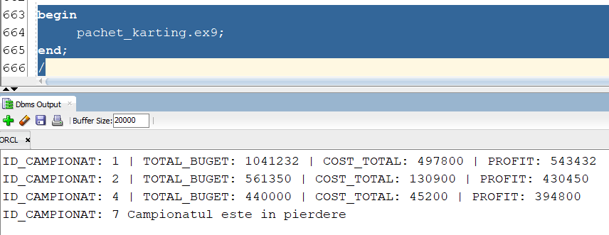

## 5 Tabele

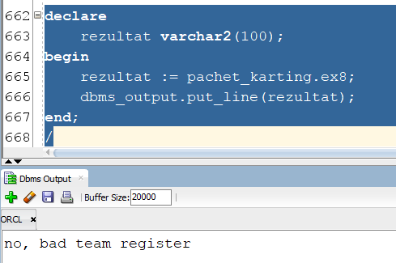

## 5 Tabele v2

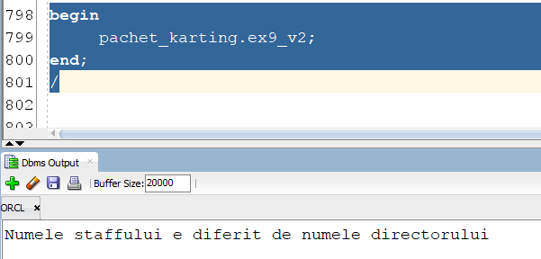

# Pachet cu tipuri de date complexe

create or replace package pachet_pilot as

procedure top3_piloti;

procedure salariu_staff;

function risc_penalizare(id pilot.id_pilot%type) return varchar2;

function lider_categorie(v_categorie pilot.categorie%type) return varchar2;

type pilot_staff is record( nume_p pilot.nume_pilot%type, id_s staff.nume_staff%type, nume_s staff.nume_staff%type);

type info_top3_piloti is record ( nume pilot.nume_pilot%type, id_mecanic pilot.id_staff%type, punctaj pilot.puncte_clasament%type);

end pachet_pilot;

create or replace package body pachet_pilot as

procedure top3_piloti as

TYPE t_top3 IS TABLE OF info_top3_piloti;

v_results_top3 t_top3;

id_ec echipa.id_echipa%type;

nume_ec echipa.nume_echipa%type;

nume_st staff.nume_staff%type;

cursor top3 is

select *

from(select nume_pilot, id_staff, puncte_clasament

from pilot

order by 3 desc)

where rownum <=3;

cursor all_staff(ec echipa.id_echipa%type) is

select nume_staff

from staff

where id_echipa = ec;

begin

open top3;

fetch top3 bulk collect into v_results_top3;

close top3;

for i in v_results_top3.first .. v_results_top3.last

loop

select id_echipa

into id_ec

from staff

where id_staff = v_results_top3(i).id_mecanic;

select nume_echipa

into nume_ec

from echipa

where id_echipa = id_ec;

dbms_output.put_line(v_results_top3(i).nume || ' a obtinut locul ' || i || ' cu '|| v_results_top3(i).punctaj || ' de puncte!');

dbms_output.put_line('Multumiri echipei ' || nume_ec || ' formata din: ');

open all_staff(id_ec);

loop

fetch all_staff into nume_st;

exit when all_staff%notfound;

dbms_output.put(nume_st || ' ');

end loop;

close all_staff;

dbms_output.put_line('');

end loop;

end top3_piloti;

--##################################################################################

--##################################################################################

--##################################################################################

procedure salariu_staff as

TYPE t_ps IS TABLE OF pilot_staff;

v_results_ps t_ps;

id_st pilot.id_staff%type;

salariu_s jobs.salariu_mediu%type;

cursor sal_st(ids staff.id_staff%type) is

select sum(j.salariu_mediu)

from ocupa o, jobs j

where j.id_job = o.id_job

and o.id_staff = ids

group by o.id_staff;

cursor piloti is

select nume_pilot, s.id_staff, nume_staff

from staff s, pilot p

where s.id_staff = p.id_staff;

begin

open piloti;

fetch piloti bulk collect into v_results_ps;

close piloti;

for i in v_results_ps.first .. v_results_ps.last

loop

dbms_output.put('Membrul staff ' || v_results_ps(i).nume_s || ' il are ca pilot pe ' || v_results_ps(i).nume_p || 'si castiga zilnic ');

open sal_st(v_results_ps(i).id_s);

loop

fetch sal_st into salariu_s;

exit when sal_st%notfound;

dbms_output.put_line(salariu_s);

end loop;

close sal_st;

dbms_output.put_line('');

end loop;

end salariu_staff;

--##################################################################################

--##################################################################################

--##################################################################################

function risc_penalizare(id pilot.id_pilot%type) return varchar2 as

pct_penalizare pilot.puncte_penalizare%type;

punctaj_invalid exception;

begin

select puncte_penalizare

into pct_penalizare

from pilot

where id_pilot = id;

if pct_penalizare < 0 then

raise punctaj_invalid;

elsif pct_penalizare = 0 then

return 'Pilotul nu are penalizari';

elsif pct_penalizare < 6 then

return 'Pilotul este in zona sigura';

elsif pct_penalizare < 11 then

return 'Pilotul este in zona de risc scazut';

elsif pct_penalizare < 16 then

return 'Pilotul este in zona de risc';

else

return 'Pilotul trebuie penalizat!';

end if;

exception

when punctaj_invalid then

dbms_output.put_line('Punctajul nu poate fi mai mic decat 0');

return null;

when no_data_found then

dbms_output.put_line('Pilotul nu exista');

return null;

end risc_penalizare;

--##################################################################################

--##################################################################################

--##################################################################################

function lider_categorie(v_categorie pilot.categorie%type) return varchar2 as

nume_lider pilot.nume_pilot%type;

begin

select p.nume_pilot

into nume_lider

from (select nume_pilot, puncte_clasament

from pilot

where trim(lower(categorie)) = trim(lower(v_categorie))

order by puncte_clasament desc) p

where rownum <=1;

return nume_lider;

end lider_categorie;

end pachet_pilot;

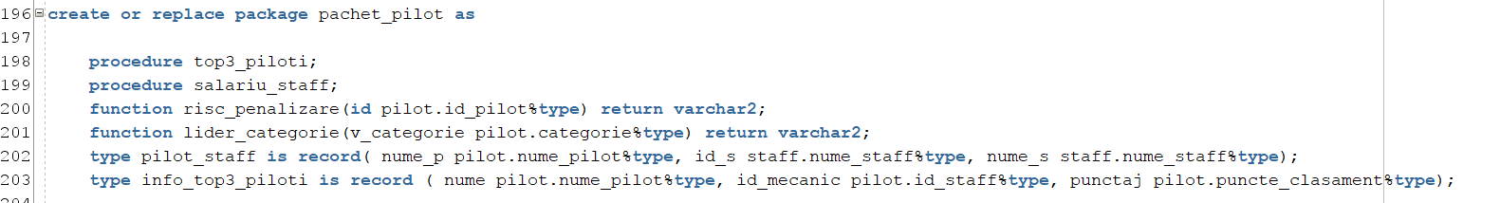

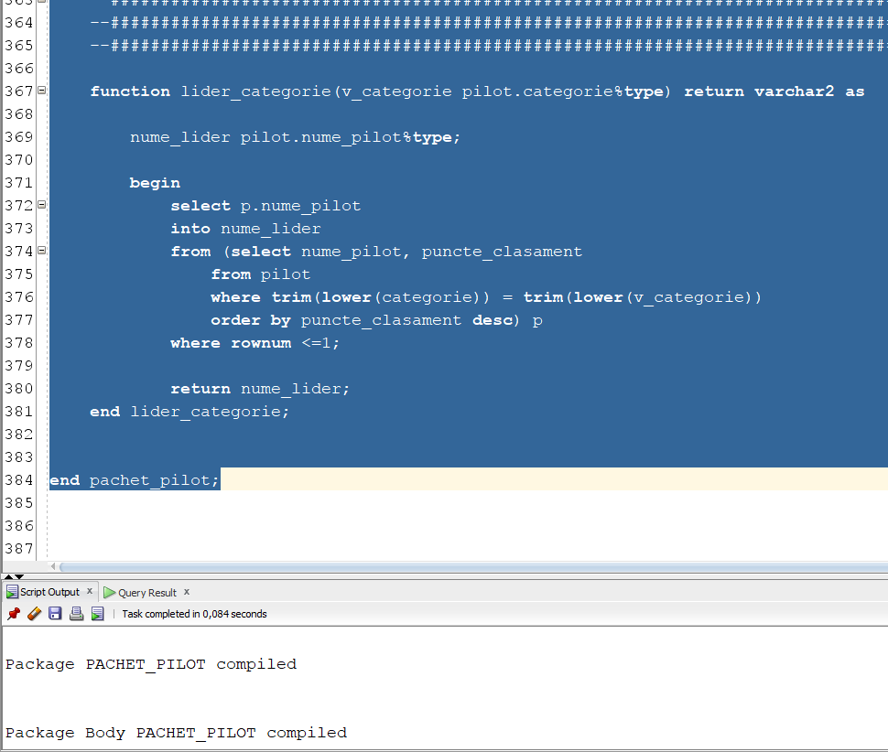

## Lider categorie

Sa se returneze liderul unei categorii date ca parametru (pilotul cu cele mai multe puncte)

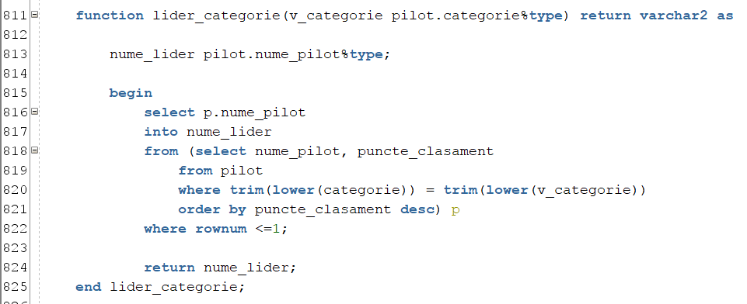

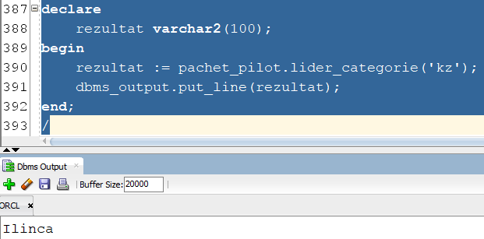

## Risc penalizare

Sa se returneze, in functiile de punctele de penalizare, gradul de risc de penalizare a unui pilot (dat ca parametru). Pana in 6 puncte pilotul nu prezinta risc, intre 6 si 10 are un risc scazut, intre 11 si 15 are un risc ridicat, iar de 16 puncte acesta trebuie penalizat.

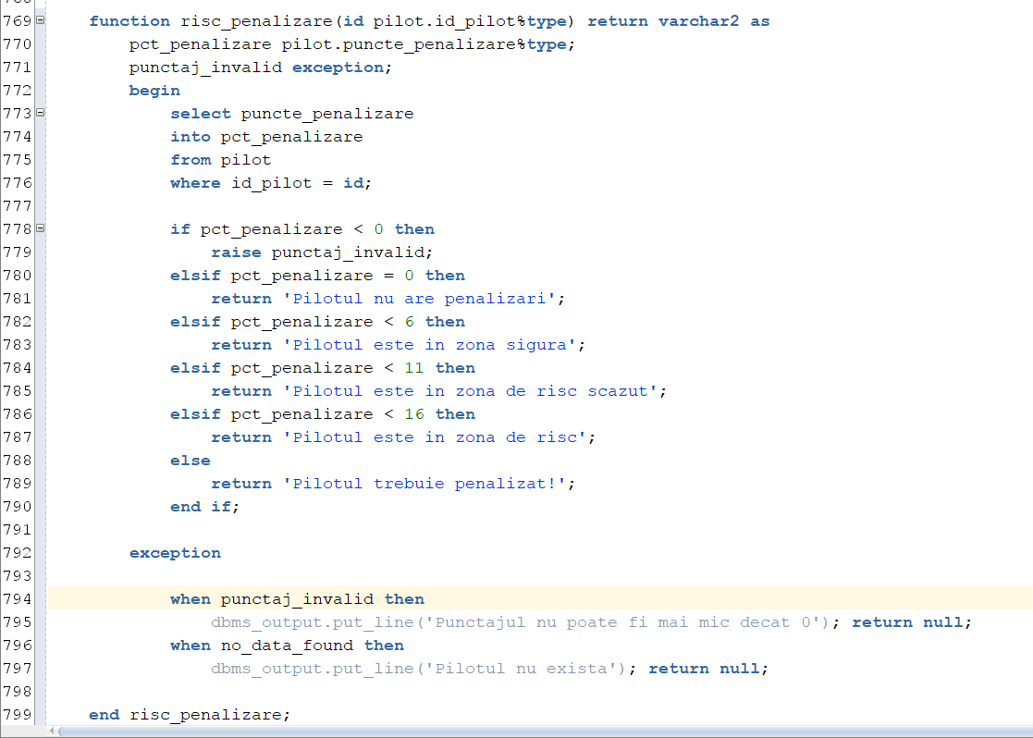

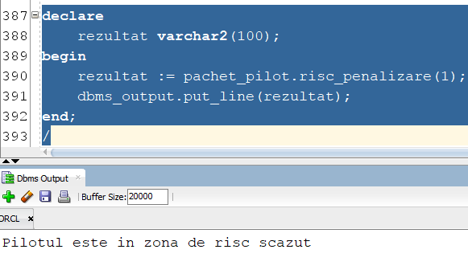

## Salariu staff

Sa se afiseze pentru fiecare pilot salariul zilnic al membrului staff ce se ocupa de el

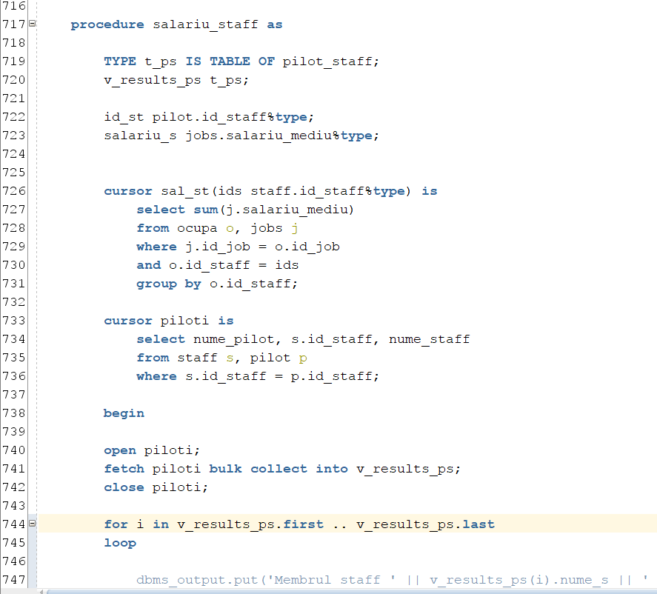

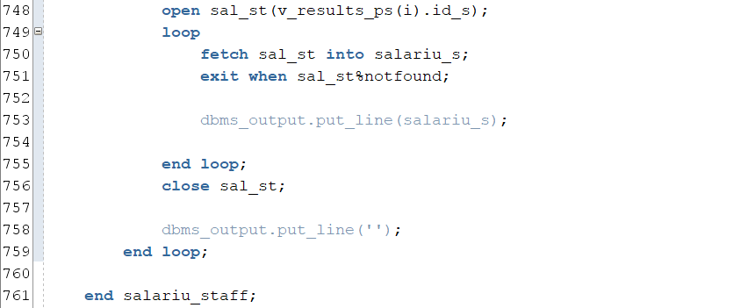

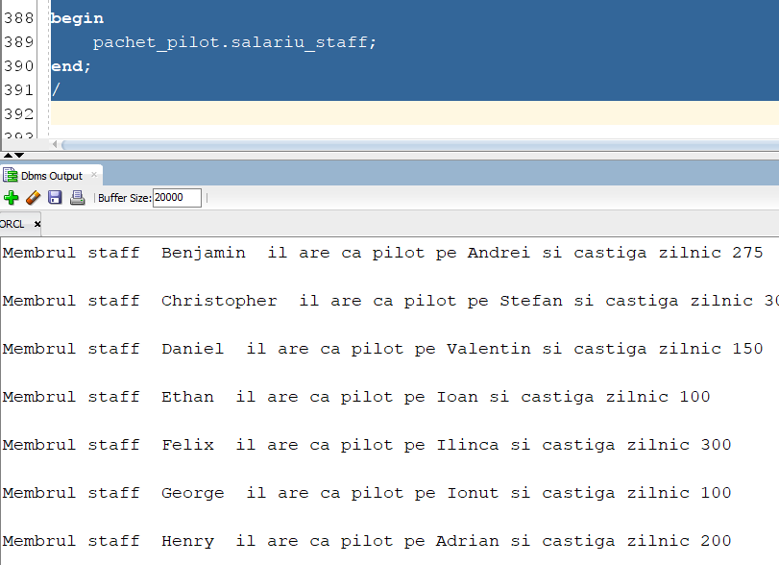

## Top 3 piloti

Pentru primii 3 piloti din clasament, afisati echipa, precum si toti membrii staff ai acesteia

